TLS

Slavery of being a girl

How do we properly judge Lee Krasner’s art?
By charles darwent
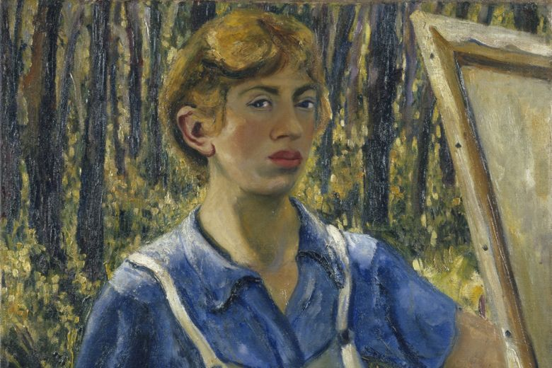
Self-portrait by Lee Krasner, c.1928 |© The Pollock-Krasner Foundation. Courtesy the Jewish Museum, New York
July 19, 2019
Read this issue

In this review
LEE KRASNER: LIVING COLOUR
Barbican Art Gallery, until September 1
LEE KRASNER
A biography
592pp. Thames and Hudson. Paperback, £12.99.
Gail Levin
Early in 1953, Lee Krasner began to glue things to canvas: pieces of her own torn drawings; photographs, burlap, newsprint; shards of discarded work by her husband, Jackson Pollock. “I’ve got something going here”, Krasner recalled thinking. Some of the pictures she used as supports for these collaged works had been in her first solo show, at the Betty Parsons Gallery in New York a year earlier. None had sold; Krasner, despairing, had taken a knife to them. The Parsons paintings would stage a comeback at the Stable Gallery in September 1955, in a show called Lee Krasner Collages. Clement Greenberg, the king-maker of Abstract Expressionism, was to call these new works “a major addition to the American art scene”.
It is a story that lends itself to allegory. The 1950s had not been kind to Krasner. She and her new husband had moved to Long Island in 1945, in the hope that leaving New York would curb Pollock’s drinking. It didn’t. By 1953, their marriage was failing. Shortly, Pollock would meet Ruth Kligman, twenty years his wife’s junior, and begin an affair with her. In 1956, while Krasner was in Paris, he would drive his car into a tree; a drunken accident that Kligman survived but Pollock did not. The collage paintings seem to anticipate all of this, Pollock’s torn artworks educing both his own self-destruction and his wife’s rage at it. This, of course, is wisdom after the fact; but the Stable paintings were to prove genuinely prophetic in another way. Six decades after they were made, and despite Greenberg’s praise of them, it is still hard to look at “Shattered Light” or “Burning Candles” without thinking, before Krasner, of Pollock.
The problem is not new. The early Abstract Expressionists, Krasner among them, had been heavily indebted to French Surrealists in exile in New York during the war. Robert Motherwell, a fellow AbEx pioneer, heretically suggested that the movement should have been called “Abstract Surrealism”. In America’s postwar imagining of herself, though, there could be no admission of foreign debt; and since the new movement was triumphantly American and the French ipso facto effete, Abstract Expressionism became a thing of whisky and chest hair. Women were not invited. As Gail Levin points out in her biography of Krasner, Irving Sandler’s defining history of the movement, The Triumph of American Painting: The story of Abstract Expressionism (1970), included no single woman artist: not Joan Mitchell or Helen Frankenthaler; Grace Hartigan or Elaine de Kooning; not Lee Krasner.
Historically speaking, there are two ways of dealing with this inequity: to face up to it, or to ignore it. Each carries its risks. Levin’s book, Lee Krasner: A biography, takes the first approach, and the exhibition called Lee Krasner: Living colour at the Barbican Art Gallery, the second. The woman who emerges from the pages of Levin’s biography is defined by the forces ranged against her – not just the misogyny of her fellow AbEx painters, but also the antisemitism of the American art world of the 1930s and, when she was older, its ageism. The book’s epigraph is from Daniel Deronda: “You can never imagine what it is to have a man’s force of genius in you and yet to suffer the slavery of being a girl”.
As a student at the National Academy in the late 1920s, Krasner was forbidden to paint still lifes with fish in them because fish were kept cool in the basement and women weren’t allowed below stairs. Prewar critics routinely attacked Jewish artists as unable to share in the “true American experience”. And not just critics: the American Regionalist painter, Thomas Hart Benton, took the same view, and vocally. One of his students was the young Jackson Pollock. When, in 1957, Life magazine eventually ran a piece called “Women Artists in Ascendancy”, Krasner was left out of it because, at forty-six, she was considered too old to be still on the rise. And so on.
All this makes for unhappy, but also problematic, reading. In the foreword to her book, Levin is emphatic that Lee Krasner did not count herself a victim. Typically, when once asked, on a form, the question, “What was the greatest sacrifice you have made for your art?” she crisply replied, “I sacrificed nothing”. Yet Levin’s punctilious cataloguing of the sacrifices Krasner unquestionably did make – by no means least, the promotion of her husband’s career at the expense of her own – tells a different story. This in turn prompts the vexed question of whether we can properly judge Krasner’s art without taking on board the circumstances of its production: whether it is, whatever else, an art of oppression, and whether we need to bring a different critical gaze to it as a result.
But which? The Barbican’s curators have dodged this historiographic bullet by keeping Krasner’s art separate from her life. The show, on two floors, is hung broadly chronologically, starting with a room of early self- portraits top right and spiralling down, bottom left, to a series of works called Eleven Ways To Use the Words To See, made in the late 1970s not long before the artist’s death.
Each stage in the progression of Krasner’s style is seen primarily in terms of the stage before, excluding fashion or outside influence or the working proximity of her husband. Signage is kept to a minimum; biography, to a video projection, set apart from the main body of the show, in which Krasner talks about her life in art in a strong New York drawl. Particularly memorable is the recollection of her German émigré teacher, Hans Hofmann, looking at one of her paintings and remarking, “This is so good, you would not know it was done by a woman”. If you do not watch this film, though, it would be possible to walk through Lee Krasner: Living colour pretty well without seeing misogyny or antisemitism, or the words “‘Jackson Pollock’”.
For the most part, this exceptionalism achieves the effect the Barbican’s curators would seem to have been after: Krasner is shown as an artist in her own right, not as an adjunct to her husband or anyone else. But this, too, has its problems. From her early self- portrait as a pony-tailed cyclops to the late Eleven Ways works, Krasner clearly saw herself in the way this show wants her to be seen, as an original, a self-perpetuating one-off. “I am never free of the past”, she said late in her life. “I believe in continuity. I have made it crystal clear that the past is part of the present, which becomes part of the future.” The trouble is that by seeing her art on its own terms as a closed loop – by liberating it from its external history – we are left with the bald question of how good it is formally. The answer to that is that Krasner was at times a very good painter, at others much less so.
This is a patchiness by no means limited to her, or to women artists; even Cézanne had his off days. But there is a nagging sense that the collage paintings she showed at the Stable Gallery in 1955 marked a high point in her career that she was never really to reach again. Canvases such as “Desert Moon” are extraordinarily powerful, not quite like anything else being made at the time; abstract, but with a graphic certainty that gives them the feel of depicting something Krasner has actually seen and known. For a decade after them, she would make big, splashy, all-over canvases much more of their day, and much less successful.
It is difficult, and possibly unwise, to divorce these from the circumstances of their making. After her husband’s death, Krasner began to work in his studio. Canvases such as “The Eye is the First Circle” (1960) see Pollock’s widow painting in what looks oddly like her dead husband’s early AbEx style. By the end of the 1960s, paintings such as “Portrait in Green”, loose rather than gestural, have the feeling of having run out of steam. Perhaps aware of this, she returned to making work that, if not actually collaged, looked that way: paintings such as “Palingenesis” (1971), whose name – “born again” in Greek – owns up to a going-back. In the Eleven Ways series, she would again re-use unsatisfactory drawings, as she had with the Stables paintings twenty years before. Now, though, the paper was cut rather than torn; and the resulting work, shorn of rage, feels knowing rather than elemental.

